Curriculum vitae

Dr. Janka Bobek-Nagy, PhD

Telephone number: +36 88 624 - 000 / 6027
E-mail: bobekj@almos.uni-pannon.hu

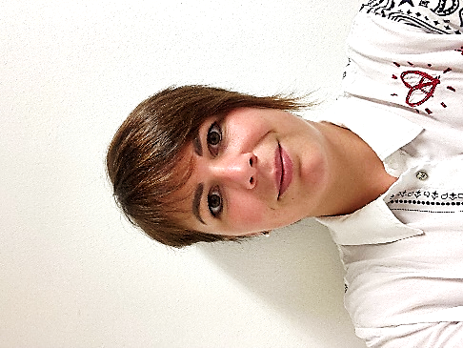

Education:
2020-2021 Research and Innovation Manager postgraduate training course (part time) University of Pannonia, Veszprém, Hungary
2016-2020 Doctoral School of Chemical Engineering and Material Science, University of Pannonia, Veszprém, Hungary
2014-2016 Chemical Engineering MA/M.Sc. (full time), University of Pannonia, Veszprém, Hungary
2010-2014 Environmental Engineering BA/B.Sc. (full time), University of Pannonia, Veszprém, Hungary
2005-2010 Secondary School of Albert Vetési, faculty of biology, Veszprém, Hungary

Szakmai tapasztalat:
2022- : assistant research fellow, Sustainability Solutions Research Lab, Research Centre for Biochemical, Environmental and Chemical Engineering University of Pannonia, Veszprém, Hungary

2019- 2022 : assistant lecturer, Department of Chemical Engineering Science, University of Pannonia, Veszprém, Hungary

2019: 6 weeks co-researching at Xi’an Jiatong University (Xi’an, Kína) research field: waste recycling, CO₂ capture, syngas production

2018: 6 weeks co-researching at Xi’an Jiatong University (Xi’an, Kína) research field: waste recycling, syngas production

2015: 4 weeks summer practice at CHINOIN Ltd. (Division of prostaglandin, Department of R&D), Budapest, Hungary
2014: 12 weeks summer work at Aqua-Terra Lab Kft., Veszprém, Hungary
2013: 6 weeks summer practice at BAKONYKARSZT Zrt., Veszprém, Hungary
2011: 4 weeks summer practice at Kis-Balaton, Balaton Uplands National Park, Hungary

Foreign language skills
English: intermediate (B2), combined, general (2008)
French: threshold (B1), combined, general (2019)

22.08.2022, Veszprém

